Assignment 01

Chandima Attanayake

2024-06-01

install.packages(“ISLR”)

1. Load ISLR and get the Data set

library("ISLR")  
data("Carseats")

1. Summary of Data set

library("ISLR")  
summary(Carseats)

## Sales CompPrice Income Advertising   
## Min. : 0.000 Min. : 77 Min. : 21.00 Min. : 0.000   
## 1st Qu.: 5.390 1st Qu.:115 1st Qu.: 42.75 1st Qu.: 0.000   
## Median : 7.490 Median :125 Median : 69.00 Median : 5.000   
## Mean : 7.496 Mean :125 Mean : 68.66 Mean : 6.635   
## 3rd Qu.: 9.320 3rd Qu.:135 3rd Qu.: 91.00 3rd Qu.:12.000   
## Max. :16.270 Max. :175 Max. :120.00 Max. :29.000   
## Population Price ShelveLoc Age Education   
## Min. : 10.0 Min. : 24.0 Bad : 96 Min. :25.00 Min. :10.0   
## 1st Qu.:139.0 1st Qu.:100.0 Good : 85 1st Qu.:39.75 1st Qu.:12.0   
## Median :272.0 Median :117.0 Medium:219 Median :54.50 Median :14.0   
## Mean :264.8 Mean :115.8 Mean :53.32 Mean :13.9   
## 3rd Qu.:398.5 3rd Qu.:131.0 3rd Qu.:66.00 3rd Qu.:16.0   
## Max. :509.0 Max. :191.0 Max. :80.00 Max. :18.0   
## Urban US   
## No :118 No :142   
## Yes:282 Yes:258   
##   
##   
##   
##

nrows <- nrow(Carseats)  
print(paste("Number of rows:",nrows))

## [1] "Number of rows: 400"

1. Find the maximum value of Advertising

M <- max(Carseats$Advertising,na.rm = TRUE)  
print(paste("Maximum value of Advertising:",M))

## [1] "Maximum value of Advertising: 29"

1. Calculate IQR

I <- IQR(Carseats$Price)  
print(paste("IQR of price:", I))

## [1] "IQR of price: 31"

1. Plot Sales and Price data

plot(Carseats$Price,Carseats$Sales)

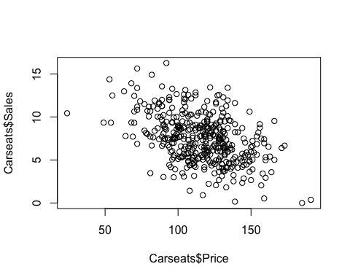

correlation <- cor(Carseats$Sales,Carseats$Price)  
print(correlation)

## [1] -0.4449507

## The correlation shows a moderate negative relationship between car seat prices and sales: as prices increase, sales typically decrease. However, this doesn’t mean that higher prices cause lower sales, as correlation does not imply causation.